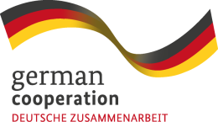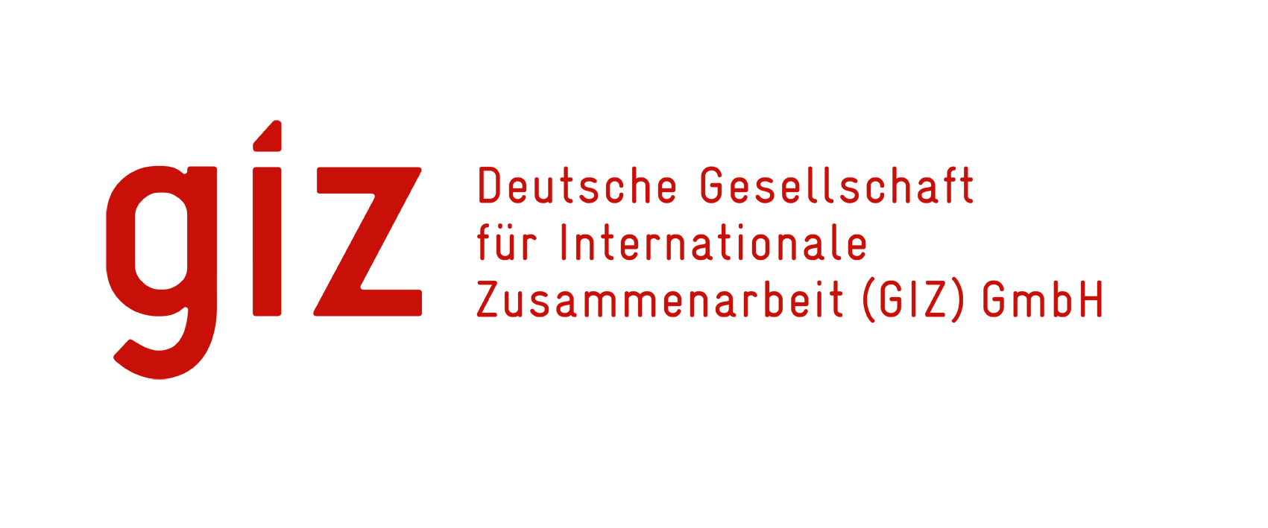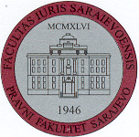
Implemented by:
PRAVNI FAKULTET UNIVERZITETA
U SARAJEVU

WORKSHOP: Collective redress in South East Europe / Kolektivni mehanizmi zaštite prava u Jugoistočnoj Evropi
Sarajevo, 28th June 2014
University of Sarajevo (Ceremonial hall)

09.30 – 10.00: Registration of participants
10.00 – 10.15: Welcome address
Representativ of the University Sarajevo

Prof. dr. Borislav Petrović,
Dean of the Faculty of Law of the University Sarajevo

Christian Reißmüller,
German Embassy Sarajevo

Prof. dr. Marko Baretić,
Vice-Dean of the Faculty of Law of the University Zagreb

10.15 – 10.30: Introduction
Dr. Christian Athenstaedt,
GIZ, Open regional fund SEE / Legal reform

10.30 – 11.15: 'An EU collective action to enforce EU legal rights; still the missing part of the Jigsaw?'
Mrs. Diana Wallis,
President of the European Law Institute

11.15 – 11.30 Coffee break
11.30 – 11.50: National report Albania (prof. dr. N. Dollani, prof. dr. F. Kola Tafaj)
11.50 – 12.10: National report Bosnia and Herzegovina (prof. dr. M. Povlakić, prof. dr. Z. Meškić)
12.10 – 12.30: National report Croatia (prof. dr. T. Josipović, Ass.-Prof. dr. A. Maganić)
12.30 – 13.30: Refreshments
13.30 – 13.50: National report Macedonia (prof. dr. T. Kamiloska Zoroska)
13.50 – 14.10: National report Montenegro (prof. dr. M. Kostić)
14.10 – 14.30: National report Serbia (Prof. dr. D. Popović, Prof. dr. M. Karanikić Mirić)
14.30 – 15.45: Panel discussion
Dr. Christa Jessel Holst and Priv.-Doz. Dr. Rainer Kulms, LL.M.
Max-Planck Institute for Comparative and International Private Law, Hamburg

15.45 – 16.00: Closing remarks

